On the Margin: Foster Youth at Risk for Human Trafficking

- It has become one of the most successful movie franchises over the last eleven years with the first of the franchise released in America in 2009.

- It relies on perpetuating human fears of a sex trafficking ring wanting to sell young girls into slavery, especially young, virgin Americans. They fetch a high price on the black market.

- The movie became iconic and redefined Liam Neeson’s career as a former government operative rescuing his abducted 17-year-old daughter by the sex trafficking ring after she arrives in Paris for a vacation.

- It gave audiences a 40-second action-movie speech that may be one of the most quoted monologues of all time. Just listen. (Put in the clip from Taken)

"I don't know who you are. I don't know what you want. If you are looking for ransom, I can tell you I don't have money. But what I do have are a very particular set of skills, skills I have acquired over a very long career, skills that make me a nightmare for people like you. If you let my daughter go now, that'll be the end of it. I will not look for you. I will not pursue you. But if you don't, I will look for you, I will find you, and I will kill you."
Of course, as you can probably already guess, movies, such as Taken, and other media, often sensationalize the trafficking of youth for the sake of box office receipts but also to the detriment of what it really means to be a trafficked youth in today’s society. They do so by relying on common myths (and creating some of their own) that distorts a true understanding of the problem and its scope within our state and local communities, Ohio being the fourth-worst state in the nation for human trafficking according to the Ohio Attorney General’s office. The other three are California, Texas, and Florida. In this presentation I want to cover some of the overall heartbreak of human trafficking and then really focus in on the costs our most vulnerable population- youth in foster care- end up paying if we don’t act on their behalf. But first let’s identify some of the myths we need to dispel before we tackle “On the Margin: Foster Youth at Risk for Human Trafficking.
- Child human trafficking only refers to sex.

- Any kind of illegal exploitation of vulnerable and marginalized human beings to make a profit is trafficking. Too often, the media focuses its attention on sex trafficking at the expense of identifying children who are forced to work long hours in poor conditions in industries such as:

Escort Services Hotels & Hospitality
Landscaping Illicit Activities
Arts & Entertainment Commercial Cleaning
Factories & Manufacturing Carnivals
Forestry & Logging Health Care
Recreational Facilities Construction
Illicit Massage Outdoor Solicitation
Residential Brothels Domestic Work
Bars, Strip Clubs, & Cantinas Pornography
Traveling Sales Crews Restaurants & Food Service
Peddling & Begging Agriculture
Personal Sexual Servitude Health & Beauty Services

- But, of course, sex trafficking, in reality, is also a form of forced labor as defined by the Trafficking Victims Protection Act (TVPA). ”Any person under age 18 who is induced to perform sex under any circumstance and for any reason (sex for food, shelter and clothing) and any person of any age, who is induced to perform commercial sex through fraud, force, or coercion are being trafficked.” It’s sad, but the only “undefined” difference between a child victim of trafficking and an adult victim is the 60 seconds before he or she turns 18 when the legal consequences change.

- Most trafficking of children happens only abroad.

- Yes, the International Labour Organization estimates that 40.3 million victims of human trafficking live on this planet with the rest of us-definitely a global problem- and that annual revenue yearly is over $150 billion. The U.N. Global Report of 2019 on Trafficking also adds that 30% are children with far more girls than boys being trafficked.

- However, the Polaris Project that also operates our National Human Trafficking Hotline, in 2018, ranked the U.S, along with the Philippines and Mexico, as the worst place for human trafficking. Since 2007, the Hotline has received more than 246,267 reports of human trafficking, with 23,784 as of June in 2019, more than 130 calls a day. Remember these are only the reported cases. In fact, most statistics you read today reveal only what is reported, leaving us only to guess at the reality we don’t know about.

- But here in Ohio during the first eleven months of 2019 the Attorney General rescued 110 trafficking victims, referred an additional 217 to services, received 359 trafficking tips, and arrested 239 people in related investigations.

- Children, however, are more vulnerable than adults. According to the U.S. Department of Health, we have more than 300,000 young people considered “at risk” of exploitation.

- In 2018, according to the National Center for Missing and Exploited Children, 14% of children reported missing were likely victims of sex trafficking and 88% of those had been in the child welfare system.

- Many of these at-risk children are raised in foster care and have a greater chance of being victimized. The National Foster Youth Institute states that as many as 60 percent of sex and human trafficking victims in the United States were once in foster care and the average age a teen enters human trafficking is 12 to 14. “Human Trafficking Within and Into The United States: A Review of the Literature.” Office of the Assistant Secretary for Planning and Evaluation. Accessed July 31, 2019, https://aspe.hhs.gov/report/human-trafficking-and-within-united-states-review-literature#Trafficking. ↩︎

- In the U.S. trafficked victims are only immigrants and foreign nationals.

  - Not so. A trafficker preys on any one who is vulnerable with a promise of a better life. A trafficker is not going to ask to see a green card or a passport before grooming the victim.
  - Risk factors for any child include prior sexual violence or abuse, unstable living situations, homelessness, poverty, generational trauma and unemployment.
  - These kids may include undocumented immigrants and foreign nationals, but we cannot overlook:
    - The LGBTQ community
    - People with disabilities
    - Racial and ethnic minorities
    - Native Americans
    - Kids with a history of substance abuse
    - Children involved in the juvenile justice system
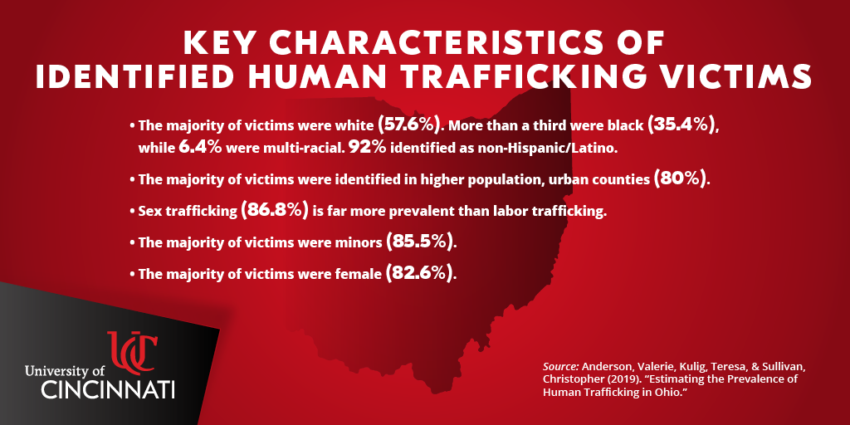

- Child victims want help to flee their traffickers.

  - Astonishingly, many child victims don’t self-identify as victims, so they don’t reach out.
  - Prior abuse or living conditions prevent them from realizing they are being exploited and manipulated. They are actively groomed for this lifestyle. They’re not asking for it, and they don’t see it coming. No kid at the age of 8 says, “Oh, I want to become a prostitute.”
  - If they do understand their situation, however, shame, self-blame, fear of rejection, fear of authorities or fear of retaliation by their traffickers may prevent them from breaking free.

- Traffickers are strangers, often stereotypical pimps.

  - Although gang members and pimps may find it easier to sell a person for sex than to sell drugs and guns, their business isn’t exclusive. A trafficker can include family members, friends (boyfriends) and neighbors.
  - Parents who need money to buy drugs are not immune to trafficking their own children. Trafficking is one of the fastest growing crimes in the U.S., and it will surpass drug trafficking within 5 years according to information from Franklin County’s Catch Court, a speciality docket court for victims of human trafficking.

- Child human trafficking could never occur in my community.

  - No state or community, both urban and rural, is immune from the reach of a trafficker, though the general public may think that most trafficking occurs in inner cities. Kids can be trafficked in farm communities as well as on the sidewalk outside of their local school.
  - The Jeffrey Epstein saga proves that there are no social, economic, or geographic barriers to human trafficking.

Statistics tell one story but putting a narrative to those statistics is what can truly be heart-breaking, especially if you are a foster care kid. The themes in each story are, unfortunately, very common.
“I shuffled in and out of an abusive home, couch surfing from one granny or uncle to the next… if it got really bad. By 10 the child welfare people came knocking, and I left my house with nothing. No toothbrush, no nothing. It didn’t get much better. I was just shuffled again between foster placements and respite care. One “mom” told me her paycheck would keep coming as long as I wasn’t dead. ‘Do whatever you want’ she said. By 14, I was. No difference between bringing in money for my mom than my pimp. He gave me tons of gifts…I was cared for. I wasn’t being blamed for anything. He said he loved me so I could overlook being sexually abused. Nobody else wanted me. No one bothered to come looking for me. My sisters in the ‘profession” all said the same thing. No one was out on the streets looking for us. No one cared.”
The reality is that someone actually is on the streets looking for these foster kids- the trafficker whose business model makes exploitation possible. That model is built around three realities we all need to address.
- Federal and state law requires that prosecutors be able to prove force, fraud, or coercion of adult victims making it important for victims to testify against their exploiters. However, victims are too scared to testify. This includes minors where force, fraud or coercion is not a factor in prosecution. Young or old, victims have been groomed to think that the traffickers are their only source of protection in this world, one aspect of traumatic bonding. Force includes being beaten or chained; fraud includes being told that a debt must be paid off; coercion may be that friends or family are threatened.
- Traffickers and buyers face minimal punishment as the laws on their side. Hugh profits are gained at the risk of low enforcement or punishment.
- Trafficking pays a very good return. In Franklin County alone it is estimated that $75,000 a day is spent on commercial sex or over $27 million a year (Catch Court) . We have 88 counties in Ohio so you can do the math. Basic economics works under the premise of supply and demand and demand is high.

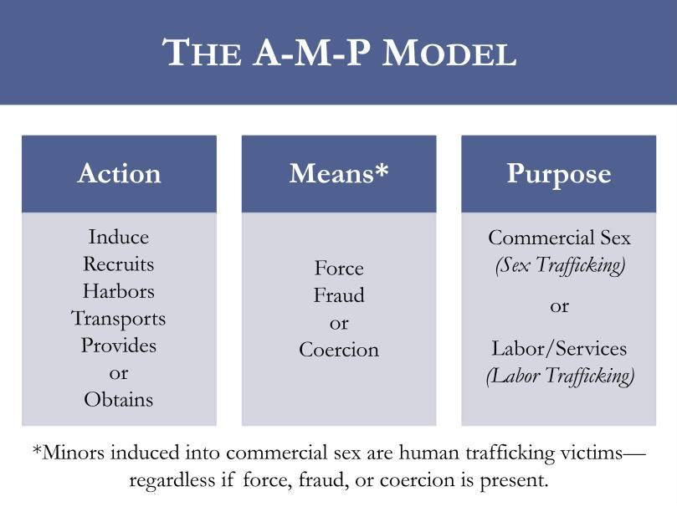
So how does the supply side of this business work, especially with foster care youth? How does the trafficker induce, recruit, harbor, transport, provide or obtain?
When a kid leaves a shopping area, she or he isn’t being kidnapped by a man in a white van forcing them into human trafficking. Sometimes, it is true, the trafficker may be looking for victims at a mall, or a bus stop, or on a street corner or in front of a school or near a group foster home, but the location is just the venue for identifying victims. Predators know all the signs of kids who don’t have family or a caring adult in their lives. They know the kids who want a sense of belonging, who come from broken homes, and who lack love or the protection of a mother or father figure. They actively look for kids with this kind of trauma history, and foster kids are the ones quickest to fall into their hands. If they haven’t been approached while in foster care, many are approached the moment they age out of foster care.
Unfortunately, today’s predator can turn to social media and to online chat rooms to make their job easier. The internet is now the number one platform for recruitment. Kids who meet and communicate with strangers online are easy prey. Traffickers have easy and anonymous access to children online where they can conceal their identity and roam without limit. Often, we have an image of traffickers lurking around school playgrounds or hiding behind bushes scoping out their potential victims (which still does happen), but the reality is that today’s traffickers search for victims while hiding behind a computer screen, taking advantage of the anonymity the internet offers.
But whether it is face-to-face recruitment, internet phishing or a combination of the two, predators use many of the same tactics:
- Befriend those foster care youth who seem lonely and emotionally vulnerable
- Pose as a peer to make friends and gain trust
- Pose as a girlfriend or boyfriend and under that guise build rapport
- Provide comfort and support to those who are cyberbullied or alienated in school
- Offer love and attention that the kids get no place else
- Invest time to break down any barriers and suspicions
- Give them gifts, a place to stay and promises of a better job or life
- Entice them with drugs and then get them hooked
- Ask for sexually explicit photos which can eventually be used for blackmail
Kids in the child welfare system don’t have the well developed skills to thwart these efforts, and before they can escape, they have fallen into the trafficker’s trap. They have little to no experience with developing and maintaining healthy relationships, which makes it easier to bond with the trafficker who will take adavantage of them. As Attorney General Dave Yost says, “ Today’s slave masters don’t use iron chains. They use addiction, fraud, and psychological manipulation, and those invisible chains hidden in the mind can be harder to break than iron links.”
Peeling back the onion as to which foster children become even more vulnerable are those who run away or are AWOL (absent without leave from a placement). They may run because they are:
- Bored
- Angry
- Having perceived or actual problems in their placements
- Romantically or sexually involved
- Wanting to visit friends or birth families
- Acting out and attempting to be in control
These kids are twice as likely to run away from foster care as are children living with their families. According to the National Center for Missing and Exploited Children (NCMEC) foster care runaways are dispropotionately vulnerable to sex trafficking. Earlier I already told you that in 2018, 88% of reported runaways who were identified as likely child sex trafficking victims were missing from a foster home or group placement home.
But as foster care youth near emancipation the risk doesn’t go away.
- Ohio is one of the top ten states with foster children aging out of foster care without a permanent home, becoming high risk to victimization by traffickers
- Close to 5500 children aged out in the last eight years
- The 913 children who aged out in 2018 experienced the following:
  - Median number of days in custody before emancipation 1852 or about 5 years
  - Average of 5 different places during this time which reduces a youth’s ability to trust and to establish permanent connections, a major risk factor
  - 25% did not have a high school diploma or GED
  - Less than 2% completed college
  - 50% experienced homelessness
  - 30% experienced incarceration
A perfect storm eventually evolves for the multiple, complex traumas these kids must live with before foster care, during foster care and after foster care. Their trauma actually changes how their brain processes information so as one victim said. “My pimp made me believe in heaven so I was willing to follow him to hell.” According to statistics from Franklin County’s Catch Court, a speciality docket court for victims of human trafficking, that hell for victims include:
- 83% having been raped
- 82% having been physically assulted
- 27% having been asssaulted by multiple assailants
- 35% having sustained broken bones
- 47% having sustained tramatic brain injuries and
- 100% addicted to drugs
Those are some staggering statistics, but we also need to consider that trafficked foster care youth may
- Miss developmental milestones
- Be deprived of education and vocational opportunities
- Be isolated from peers and mainstream society
- Be disconnected from school and from community
When we realize that 60% of all trafficked adult victims had been in the foster care system as youth and that their emotional exhaustion and brokenness begins at an early age, we can recognize the death look, the hollow look in their eyes. The trust they once freely gave to others as children makes their lack of trust in anyone or in any institution so readily understandable. They have learned that their bodies belong to someone else and that they are in the power wheel of the trafficker. The goal of the trafficker is to get the victim to fear death and yet be grateful to the trafficker for being alive. The goal of the victim is just to live another day.

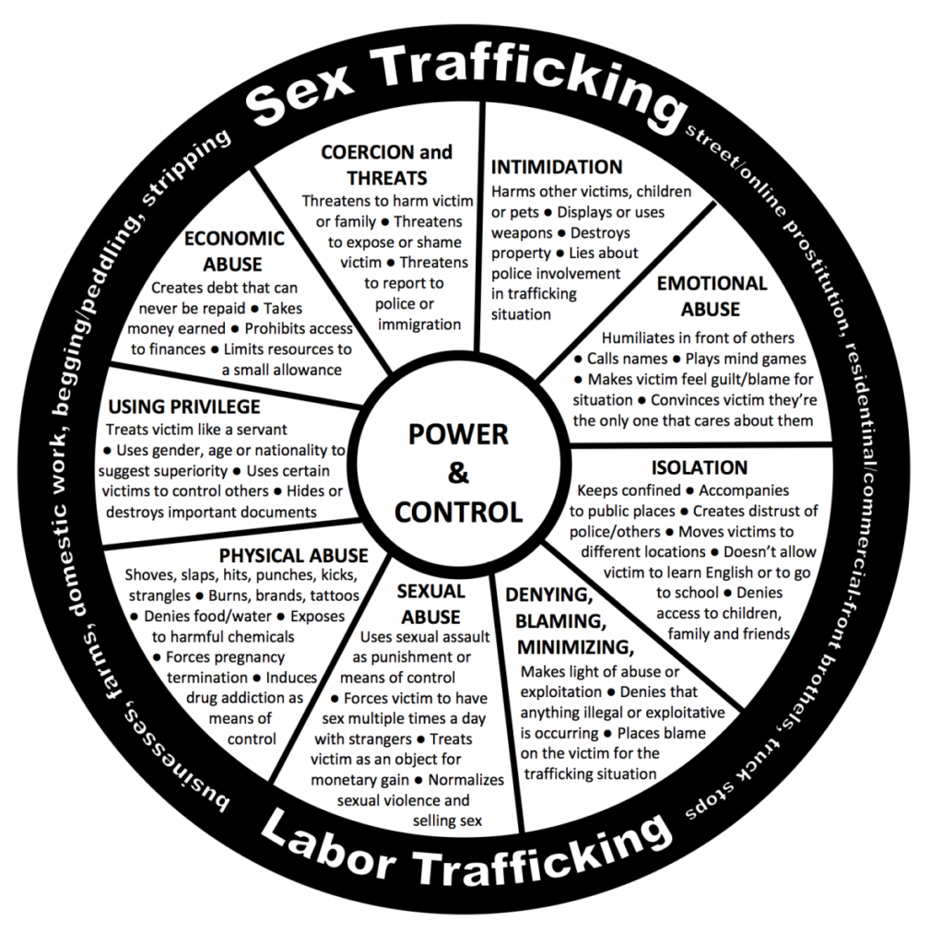
Recently, The Ohio State Supreme Court published Juvenile Human Trafficking, Ohio Laws and a Safe Harbor Response Bench Card to help us all see other red flags we should be aware of, especially as we encounter foster youth within the justice system.
Underlying Circumstances Red Flags
- Multiple places with minimal social support
- Homelessness
- Disconnected from family
- Guardianship by unrelated adult or older male/female friend
- Family history of prostitution or solicitation
- History of physical or sexual abuse or neglect
- History of domestic violence or family dysfunction
- Unsure or unwilling to give “home” address or identify other household members
- Fearful of consequences for not following rules, e.g. returning “home” at set times
- Lives in a hotel or reports frequent travel to other cities
- Concerned about immigration documents or status
This narrative arc continues when factoring in the emotional and behavioral red flags that identify potential trafficked victms.
Emotional and Behavioral Red Flags
- Signs of trauma
- Unusually paranoid or fearful
- Emotional extremes, such as numbness, dulled affect, depressed, low self-esteem or submissive, or angry, defiant, belligerent, or defensive
- Guilt and shame
- Significant changes in behavior, e.g., falling asleep in school, overtly sexual, preoccupied with money
- Hanging around much older men or women
- Increasingly truant or absent from school
- Gang affiliation
Health Red Flags
- Substance use and abuse
- Unexplained bruises or injuries, e.g., broken bones, burns, or cuts
- Signs of prolonged, undiagnosed, or untreated illness or disease, e.g., bed bugs or other parasites, or frequent bladder or yeast infections
- Signs of malnourishment or excessive hunger
- Signs of extreme fatigue or exhaustion
- Sexually transmitted infections
- Multiple pregnancies, miscarriages, or terminations
- Chronic dental problems
Appearance Red Flags
- Inappropriately dressed for weather, location, or age
- Branding or tattoos, e.g., boyfriend/girlfriend or friend’s name, gang, or other symbol as if indicating ownership
- New hairstyle, professional manicure, clothes, shoes, electronic or expensive gift
- Large amounts of cash, prepaid credit cards, hotel keys, receipts, matches, or multiple cellphones
- Non-verbal communication with an unrelated adult, e.g., seeking approval before answering questions
- Presence of an overtly controlling or concerned older male or female friend

(Insert pictures and video here)
Obviously, the devastation wrought by human trafficking is heart-wrenching and grim. No age, gender, ethnicity, race or socioeconomic status is spared, but when the victim is the vulnerable foster child among us, the moral obligation to do something rests squarely on all of our shoulders.
In Ohio, that Attorney General’s Office- through its Human Traffic Initiative, Human Trafficking Commission, Ohio Organized Crime Investigations Commission, Bureau of Criminal Investigation and Ohio Peace Officer Training Academy- has made trafficking a priority. The AG’s office is forming multidisciplinary teams and is working throughout the state alongside other law enforcement agencies, social- service agencies, nonprofit agencies and anti-human trafficking coalitions to address the scope of the problem by, for example,
- Cutting demand by catching, shaming, and punishing people who attempt to buy sex, especially from children
- Pushing to change state laws, educate law enforcement officers and prosecutors
  - State Senator Teresa Fedor just recently introduced the Protect Trafficked Minors Act that will eliminate the current two-tiered system in child sex trafficking laws.
  - Currently, prosecutors must demonstrate force, fraud, or coercion for a 16-or 17-year-old to qualify for the protections available to other minors, creating some gap years for foster care youth, as well as other youth.
  - This act will bring Ohio into compliance with federal law and provide additional resources for all anti-human trafficking effort in the state. Ohio is the last state in the nation to be incompliance with federal law.

- Connecting groups to share best practices and provide resources so that improved responses can take place in every Ohio community

- Developing trust with victims and steering them to services that can change their lives

As a sidebar here, many of our foster care parents are trained to remain on high alert about their charges and human trafficking. As lawyers and other community members, we, too, can learn the early warning signs as we interact with foster care youth.
- Do they have a cell phone, money or other items not given to them?
- Do they post sexually explicit material on the internet or in chat rooms?
- Do they participate in a sexual act to obtain alcohol, drugs or anything else of value?
- Are they friends with an overly controlling person?
- Are they changing friends?
- Are they having an extreme change of habits? Tattoos or branding?
- Do they show signs of physical and/or sexual abuse?
If these questions elicit “yes” answers, then we can also learn from foster parents some of the best approaches to take to address concerns and to develop trust.
- Be nonjudgmental, patient and consistent in your conversations
- Show that you care and won’t be upset based on what they reveal to you
- Educate them on human trafficking and what to look out for
- Discuss the dangers of social media and engaging with people they don’t know
- Monitor activity on computers, phones and apps
- Seek out help from other professionals, especially caseworkers
- Listen when the child talks
- Identify and address the child’s needs
But as we focus on the kids in foster care who can fall victim, we also need to see how Ohio’s Safe Harbor Law provides protection. If a court has reason to believe that a juvenile is a trafficking victim, the court, under Safe Harbor provisions, can hold in abeyance the charges against the juvenile and/or the juvenile’s criminal history. The court through a series of protocols can then make diversion recommendations to protect and support the victim. R.C 2152.021 (F), including appointing a guardian ad litem separate and apart from defense counsel R.C. 2152.021 (F) (3) and allowing minors under 16 give testimony in preliminary hearings via closed circuit television ORC 2937.11 (D) (1) (a). As of today only five or six counties in Ohio are regularly using the Safe Harbor Law so lots of education needs to be done.
Restore Court, a specialized docket court in Summit County, has integrated Safe Harbor provisions in its efforts to protect and stabilize youth in the community. Its mission is to help high risk juveniles achieve successful lives by providing wrap-around-services for holistic help.
- Mentoring…. through Rehab Ministries in Akron
- Counseling….partnering with community agencies who use trauma-informed therapy
- Case Management…paired with a case worker to link youth and family to community resources
- Supervision & Accountability….assigned to probationary supervisor
The program tracks for Restore Court include:
- Safe Harbor Track- charges can be dismissed and expunged upon graduation from the program
- Traditionsal Track- for those involved with trafficking but who do not meet the criteria for the Safe Harbor statue
Others across our state are also being trained and educated to think about what trafficking actually looks like.
- In 2018, Congress passed SOAR, a federally funded training program for health care workers that gets doctors, paramedics, nurses and others to

    - Stop
    - Observe
    - Ask
    - Respond

- Trafficked victims experience injuries, sexually transmitted diseases and problems with everything from cardiovascular health to dental problems, and a emergency department worker may be able to connect the dots between a broken bone and trafficking if he is trained to see the link and know the red flags we discussed earlier. Once that is done health professionals can then connect victims to relevant services if they suspect human trafficking.
- One study found that nearly 88% of victims interact with a health care worker at least once while being trafficked.
Schools can also have a part to play as teachers and students learn the reality of human trafficking and address it in their midst. For example, students at North Fork Local Schools in Licking County (a rural community) will participate in a year-long, anti-trafficking Prevention Program designed by the Richmond Justice Initiative, a faith-based nonprofit headquartered in Virginia. They will be the first district in Ohio to do so.
- Ohio will be the 11th state to have the curriculum taught
- Lesson plans are broken up by grade level (middle school and high school)
- Students will learn the red flags of trafficking
- Students will learn online safety and importance of self-esteem
- Teachers will be trained to teach the material, making them trusted adults to approach about the topic
And finally, The Ohio Department of Job and Family Services, working collaboratively with member agencies throughout the state, is providing housing and other case management services for young adults who leave foster care on or after their 18th birthday but who are not yet 21. Bridges is a new aging- out program that promotes permanent connections and social networks for vulnerable foster care youth by
- Poviding safe, stable, and healthy housing
- Linking participants to physical and behavioral health services
- Teaching daily living skills for lifelong self-sufficiency
- Offering educational and employment opportunities and
- Building skills for self-advocacy
Instead of being taken in by traffickers to survive, foster youth meet with Bridges support staff to tailor services to their unique needs. This year our Fellows at the Ohio State Bar Foundation in a program called, “Stuff the Suitcase,” provided basic supplies in a suitcase for aging-out foster youth. Bridges was then able to distribute those suitcases to those in need, an on-going and hands-on project that people can undertake in any Ohio community.
As I close today, I want to introduce two more myths I hope you will immediately recognize as false.
- Trafficked kids will just return to being trafficked…nothing can really be done.
- I can do little to address this huge problem.
You might not be Liam Neeson from Taken with a “particular set of skills” to go after the bad guys, but you have taken the first step tonight. By dispelling the myths that immobilize action, by recognizing the red flags of human trafficking, by understanding what others around our state are doing, you now know that trafficked foster care kids are truly victims of a traumatizing violent crime through no real fault of their own. Their behavior can now be viewed in light of what we can do in our own community to make a difference. At the very least, if you see something, then say something and consider the following both in your professional and daily lives:
- Build community awareness person-to-person and through your social media platforms
- Support legislation that addresses the reality of human trafficking in Ohio
- Avail yourself of human trafficking training and practice trauma-informed care
- Watch for red flags and report to authorities
- Assist victims and offer support and overcome the stigma associated with this crime
- Contact Children’s Services and local police if you suspect abuse and/or trafficking
- Volunteer and support agencies in the community who work with foster care children
- Call the National Human Trafficking Hotline (888-373-7888) to report trafficking
- Report emergencies by calling 911
- Encourage local schools to get involved
- Become a mentor to a child in need
- Offer legal services when appropriate
- Let your heart guide as you individually make a difference in a foster care child’s life

FYI from Bev Graves
Lisa Ray and I attended the 11th Ohio Human Trafficking Awareness Day at the Statehouse on Feb .27, 2020. While attending the Legal Panel moderated by Klodiana Tedesco, I took some notes you might find interesting as you present. These will be a short hand version which may pique your interest to do further research.
Brandon Standley, Chief, Bellefontaine Police Department
- Major gaps in police training about trafficking and how to handle victims, especially in small towns and villages… not seeing the victim as a victim…stereotype and stigma
- Humans are traded for drugs- big issue
- Kid washing dishes in back of restaurant needs to be viewed differently. Whose child is he? Runaway? Need to investigate?
- Middle school kids are at great risk- no longer in after-care services, mostly at home online
- Need boots on the ground, street by street
- Faith-based groups have a lot of power
- A survivor questioned Standley: “Police were my enemy. They thought I was just a bad person. What are you doing about that?”
Amy O’Grady, Deputy Solicitor General, Columbus City Attorney Zach Klein
- Officers and agencies need to be educated…they investigate but don’t often have the tools to prosecute
- The justice side must be reformed. Many convicted victims don’t know the alternatives they have such as Catch Court, even after multiple convictions
- We sometimes actually keep people in jail for their safety
- Early intervention is key
- The system needs to take more time with people
- Detox is often the first issue confronting us
- Defense attorneys are conflicted at times…must represent client’s wishes even though attorney wants to follow a path that will help the client to long term recovery
- Need to tap into social services more but how do I represent the interests of my client, especially if unwilling
Heaven DiMartino, Assistant Prosecutor, Summit County
- Victims aren’t chained, aren’t being followed so how can you say they are trafficked when encountering on the street
- Mental and emotional manipulation are the bonds
- Look for red flags
- Many may be kicking and screaming when pulled out of abusive environment…trust the pimp more than the police
- Must build trust as a prosecutor but not easy
- Must provide counseling, housing and employment…how to connect victims with necessary social services
Barbara Freeman, Survivor and Founder of the Freeman Project part of The Switch National Human Trafficking Network working to end exploitation of women and girls. It is the mission of The Freeman Project to house women in transition as a step over from local rehabilitation and correction facilities. She discussed remaining challenges.
- Big need for peer recovery support
- Develop partnerships in housing…victim can recover, even for a few years, but if she ends up back in the old neighborhood because of housing and employment needs, what option does she have but to go back to the pimp
- Develop some equal opportunity in employment…give victims a fair chance to learn and to succeed
- Need better health care, especially mental health care
- Need more detox and recovery places… victims have to wait too long to get into treatment…Maryhaven in Columbus will give a victim a two hour assessment and then say it will call in two weeks…victim just spilled her guts, has no phone and nowhere to go. What is she supposed to do…this is a lot harder if he or she is undocumented
- Get into the schools and educate…kids line up and ask me all kinds of questions…they want to help
- We have the money…quit putting it in dumb places…develop more safe houses
- We need to address higher levels of traumatized backgrounds…not easy and takes time and commitment
- Things won’t change unless law enforcement and the justice system becomes educated and changes
- If DUIs have special license plates, why not pimps and johns
- Stop stigmatizing

Resources
Addressing Child Sex Trafficking from a Child Welfare Perspective. www.casey.org/media/child-sex-trafficking.pdf
Child Welfare Capacity Building Collaborative, The Children’s Bureau, U.S. Department of Health and Human Services. www.learn.childwelfare.gov/content/child-welfare-response-child-and-youth-sex-trafficking
Dignity Health’s Human Trafficking Response Program. www.dignityhealth.org/human-trafficking-response
Domestic Abuse Intervention Project’s Duluth Model Power and Control Wheel. www.theduluthmodel.org
Forced Labour, Modern Slavery and Human Trafficking (International Labour Organization). www.ilo.org
Human Trafficking and Child Welfare: A Guide for Child Welfare Agencies. www.childwelfare.gov/pubs/trafficking-agencies
www.humantraffickinghotline.org/
Human Trafficking in the US: Misconceptions vs. Reality. www.u.osu.edu/osuhtblog/2018/03/06/human-trafficking-in-the-us-misconceptions-vs-reality/
“Human Trafficking Within and Into the United States: A Review of the Literature.” Office of the Assistant Secretary for Planning and Evaluation. Accessed July 31, 2019. www.aspe.hhs.gov/report/human-trafficking-and-within-united-states-review-literature#trafficking
Juvenile Human Trafficking, Ohio Laws and Safe Harbor Response. www.supremecourt.ohio.gov/resources/juvenileHumanTrafficking
National Center for Missing and Exploited Children. www.missing.kids.com
www.OhioAttorneyGeneral.gov/HumanTrafficking
Ohio Department of Job and Family Services/ Bridges. www.bridgestosuccess.jfs.ohio.gov
Ohio Human Trafficking Task Force. www.humantrafficking.ohio.gov
Polaris. www.polarisproject.org
www.rahab-ministries.org
Sex Trafficking: Sex and Human Trafficking in the U.S. Disproportionately Affects Foster Youth. www.nyfi.org/issues/sex-trafficking

SOAR to Health and Wellness Training/Office on Trafficking. www.acf.hhs.gov
Specialized Court Dockets: Catch Court & Beyond. www.u.osu.edu.osuhtblog/2018/04/15/specialized-court-dockets-catch
TeachTrauma. www.teachtrauma.com/information-about-trauma/types-of-trauma
The Actions Means Purpose (AMP) Model. www.humantraffickinghotline.org/resources/actions/-means-purpose-amp-model
The Freeman Project. www.thefreemanproject.com
The Prevention Project- Richmond Justice Initiative. www.richmondjusticeinitiative.com
The SWITCH National Anti-Human Trafficking Network. www.jointheswitch.org
Top 15 Myths about Child Trafficking. www.pact.city/top-15-myths-child-trafficking/
What You Need to Know About Foster Care and Human Trafficking. www.safy.org/what-you-need-to-know-about-foster-care-and-human-trafficking/

